MACHINE LEARNING FINAL PROJECT

(O4)

ITMAL-01

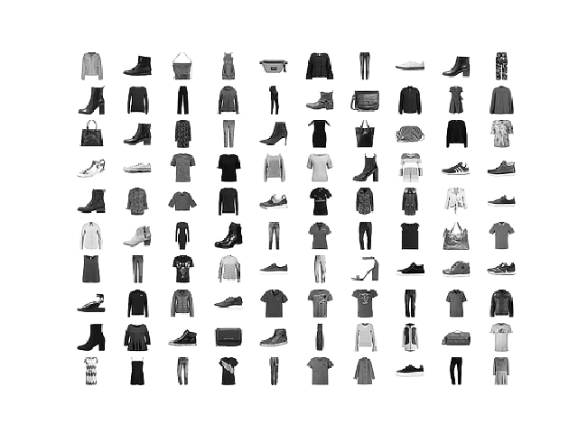
Due date: 05-12-2019

Gruppe 27
Christopher Thomas William Bernold – 201611828

Problem statement
This project tries to solve the issue that arises when working with the standard MNIST dataset, that it can be too easy a dataset when benchmarking machine learning algorithms. MNISST has the disadvantage that the pictures do not have very many features, which can result in the models producing inaccurate results on other datasets even though the model had achieved a high score with the classic MNIST dataset. Zalando has tried to create a solution for this issue, with a “replacement” dataset called the Fashion-MNIST dataset, which is a dataset containing 10 different clothing articles each holding many features. This paper tests if even linear classification can be used to obtain just as high results as comparison to the classic MNIST dataset.

Dataset
This assignment is based on the Fashion-MNIST dataset which contains Zalandos article images. The dataset contains a training set of 60.000 examples and a testset containing 10.000 examples. Each example is a 28x28 grayscale image which is a total of 748 pixels. Each image is associated with a label, where there all together are 10 labels to mark the difference clothing articles. Shown in table 1 is every clothing item that can be found in the dataset.
0 | 1 | 2 | 3 | 4 | 5 | 6 | 7 | 8 | 9
T-shirt/top | Trouser | Pullover | Dress | Coat | Sandal | Shirt | Sneaker | Bag | Ankel-boot

  - Table 1: Alle tøj typer i datasættet.
In the final project proposal, the dataset was found on the Kaggle website, but since the dataset is already part of the Keras library and can easily be loaded using Keras, the dataset is instead taken from there. The train and test data already comes pre-shuffled which means that this does not have to be accounted for.

ML Algorithms
In this assignment the primary focus will be working with a convolutional neural network (CNN) for image classification trying to score the highest accuracy possible.
beskriv f.eks.
- hvilken grundliggende ML algoritmeklasse(r) valgte i (supervised/unsupervised, regression/classifikation)?
- hvilke kriterier lå til grund for jeres model selection?
- hvorfor er jeres valgtealgoritme god til netop jeres dataset?
- hvad er fordele og ulemper ved den (eller de) valgte algoritme(r), f.eks. kompleksitet?

ML pipeline:
beskrivelse af hvordan i splitter data i train-test set, preprocessere, træner og tester.

Optimization and regularization
An effective strategy to overcome over/underfitting is using regularization. In this assignment, two methods of regularization for the convolution neural network were considered to overcome overfitting which arises when not applying any regularization. The first strategy used is the dropout method. Here in each step of learning a random subset of the units is chosen and ignored. This set of unit is ignored both on the forward pass through the network as well as in the back propagation stage.
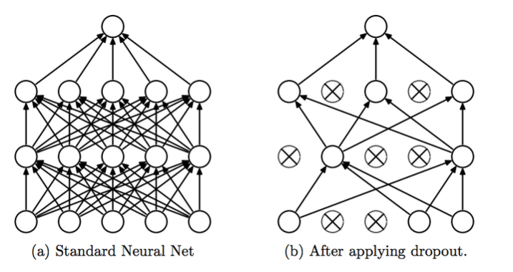
Figure 1- difference between a fully connected network and a network with dropout applied
The dropout regularization method can in many cases of CNN’s work very well. This is due to allowing to train many different networks on different parts of the data. Each time the network that is trained is randomly chosen from the full network. If the network becomes to sensitive to the noise in the data other parts can compensate for this, due to not being exposed to the samples with effecting noise. If one unit were to be trained to prefer i.e. vertical lines and another unit horizontal lines, preventing the units to be overly correlated in their activity.
Using Keras dropout is implemented as a layer after the layer where units need to be ignored. Here the proportion of the units in the layer that need to be ignored in each learning step are defined. This value is a “fine tuning” measure where the value can be tweaked to optimize overfitting, which happens to occur without regularization. In the first second and third layer 25% of all units are ignored, which happens to yield the best results.
How does the model look without any regularization added?

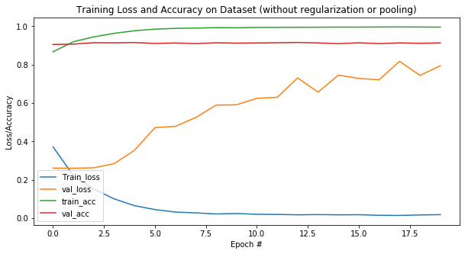
Figure 2- Training loss and accuracy without regularization or pooling using 20 epochs
Figure x shows that there is a very high training accuracy, averaging around 99.5%, but given the validation loss increases so drastically per epoch the model proves to overfit. In this basic “core model” no pooling is added as well, which also alters the validation loss greatly. One of the challenges in fitting neural networks is the fact that most of the time they contain large numbers of parameters. Based on the model used without pooling or regularization containing three convolutional layers, there are around 1.5 million parameters to work with, which is visualized with summary().
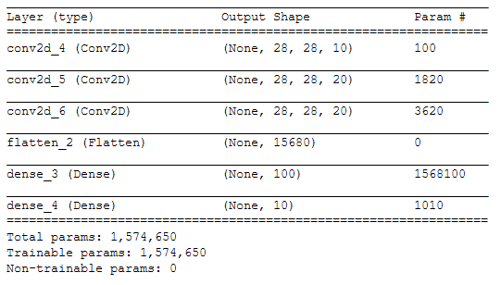

To mitigate this issue, we can summarize the output of the convolutional layers in a concise matter. This can be achieved using pooling operations. Here there are three types of pooling operations, max pooling, min pooling and average pooling. Here each operation does different things. Max pooling summarizes a group of pixels based on its maximum value, min pooling does the same but just with the minimal value. Average pooling summarizes the average value of all the pixels instead. In this assignment average pooling is used to minimize the number of parameters. “Visually” when looking at an image where pooling has been applied it typically looks more pixelated and blurrier as the number or pixels from the original picture has been decreased. Pooling is not a regularization technique even though it can help decrease the validation loss, it is simply a part of the model’s architecture, which means it is used during evaluation. The reason that the validation loss is decreased when using a pooling operation is due to down-sampling the input representation, the model becomes less sensitive to some translations. After applying average pooling to the first model without regularization (on the first and second convolutional layer), the number of parameters decrease greatly:
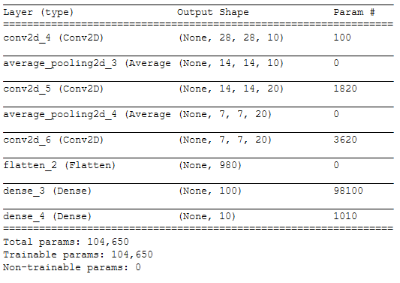
After fitting the model and plotting the results, we achieve a model that does not overfit nearly as much, but still enough to effect generalization.

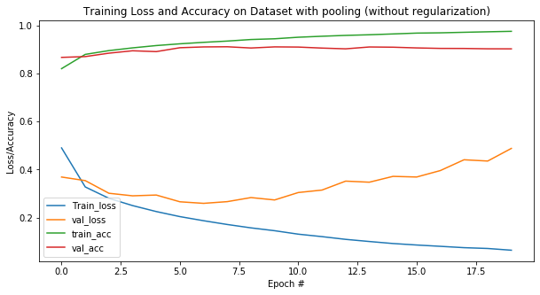
Figure 4- model with pooling but no regularization
To finally fix the overfitting issue dropout regularization is added:
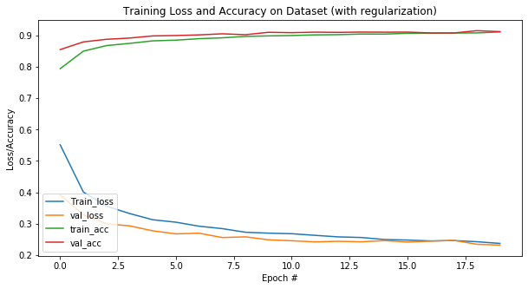
Figure 5- Training loss and accuracy with regularization using 20 epochs
Based on the two figures showing training loss and accuracy on the dataset with and without regularization, there is a vigorous difference. Here adding average pooling to decrease the number of parameters to work with and adding dropout on all three convolutional layers we end up with a model that generalizes better than without regularization and pooling. Based on a classification report with the final model, we receive the final results.
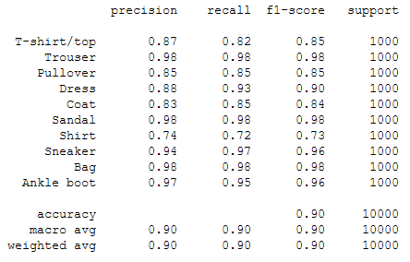
As the results show, the shirt class does not perform very well compared to other classes.
The second form of regularization that proves promising results in convolutional neural networks and was considered a strong choice for this assignment, is batch normalization. Here the output of a layer is taken and rescales it, so it always has a zero mean and a standard deviation of one in every batch of training.
Since dropout slows down training during to its incremental and careful procedure, batch normalization speeds up the process, this can then cause the two methods to counter each other and cause the network to perform worse when used together than compared if neither of the two were used. Based on this fact the network only uses dropout as its regularization technique.

Performance metrics:
beskrivelse af, hvordan i måler 'effektiviteten' af jeres træning og test.

Conclusion

Image found on DataCamp course for convolution neural networks https://campus.datacamp.com/courses/convolutional-neural-networks-for-image-processing/understanding-and-improving-deep-convolutional-networks?ex=4
https://ai.stackexchange.com/questions/9563/is-pooling-a-kind-of-dropout/9566

